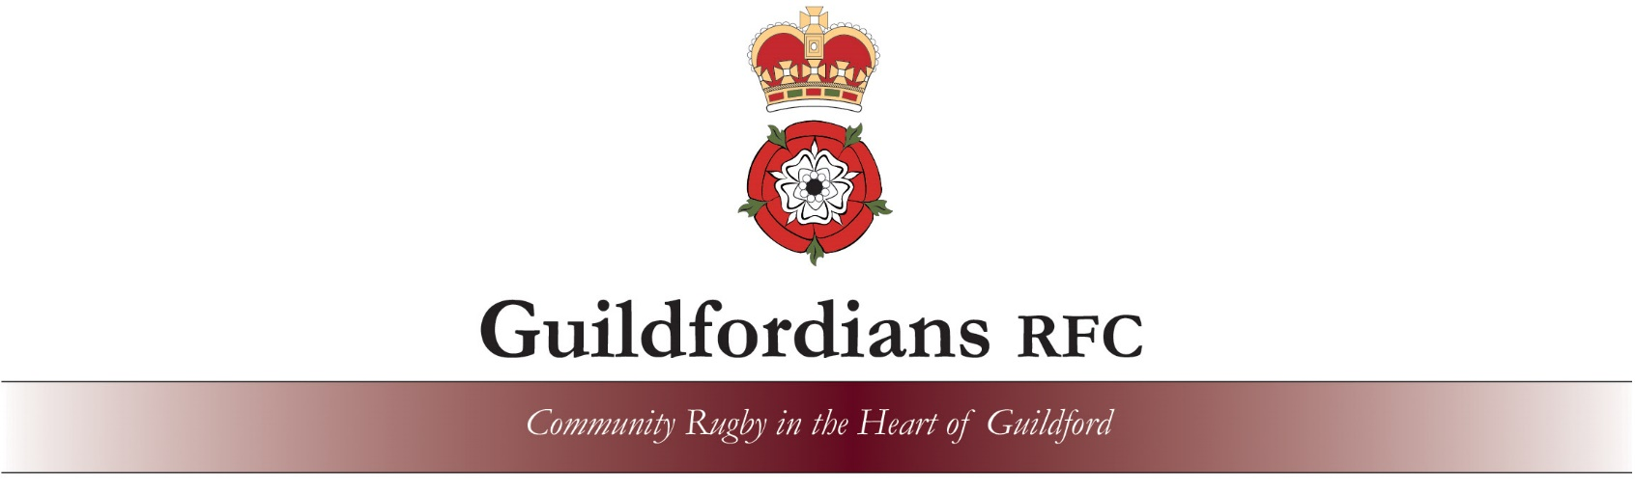

Festival Player Registration 10th March 2024
Club: |  | Age Group:
Lead Coach: |  | Team (e.g. Red/Blue):  (if more than one entered at this age group)
Referee:
Each SQUAD entered must provide a referee.
All age groups – Mixed Ability Squads

Max. per Team |  | Players Name | Date of Birth | RFU Number
U7 Maximum | 1
 | 2
 | 3
 | 4
 | 5
 | 6
U8 Maximum | 7
 | 8
 | 9
 | 10
U9 Maximum | 11
U10 Maximum | 12
U11 Maximum | 13

To save time on the day, please complete this form in advance with the details of allowable players for each team in your age group and email to: minis.fixtures@grfc.co.uk

Photography: The RFU has published guidelines on the photography of children. All clubs entering our festival are asked to agree that parents taking photographs of their child(ren) do so as part of the normal course of rugby activity and that the images may be used in club publicity or local press, in line with RFU guidelines for the welfare of young people in Rugby Union.

