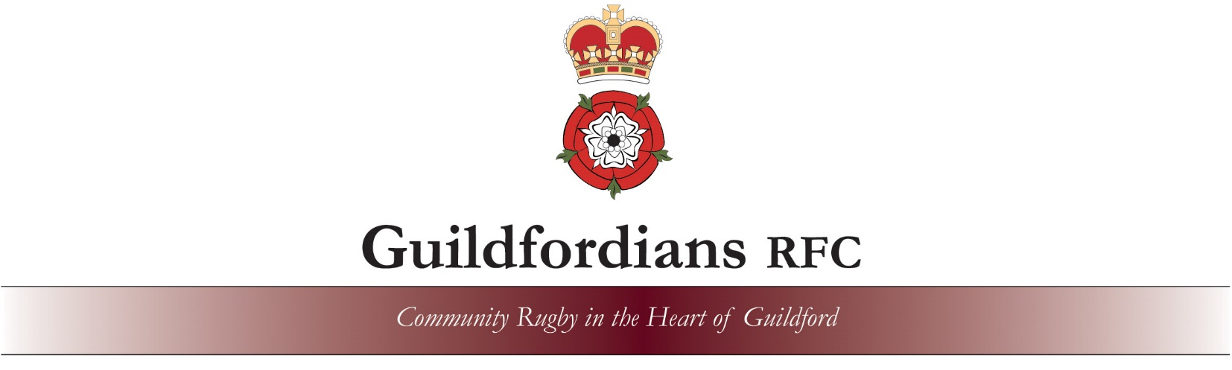

Account Creation, Membership and Player Registration via the RFUs Game Management System (GMS)
We hope that this document will help guide you to complete some tasks on GMS, if you run into problems please see the Known Problems section. We will try to keep this updated with any new issues we find. The document last updated on 22/02/2024.
There are a number of parts to the process, some a one of and others seasonsal :
Create an account for an adult (one time process when you first join the club).
Associate to the club (organisation - one time process)
Add Junior players to the account if applicable and associate to the club (organisation - one time process)
Junior players need to register (it was called affiliation in the 22-23 season – seasonal process)
Adult players need to register (from the 24-25 season – seasonal process)
Membership Fee (parents do not need to pay membership unless they are planning to also play rugby – seasonal process)

Content
Create Account : (if new too club rugby – if previously at another club you should already have an account)
Log In to GMS :
New Player :
Adding a New Junior Player to your Account :
Associate to Guildfordians RFC
Register Junior Players ( Age 3 to 18 )
Register Adult Players ( new for 2024/25 season )
Purchase Membership
Known Problems / Issues

Create Account
If you have been a member of a rugby club before you will probably already have an account in GMS so please try the Log In to GMS option first. If that doesn’t work please create an account (you have to be 18 years old to own your own account otherwise a parent will need to create an account for you and then add you).
Go to webpage : https://gms.rfu.com/GMS/Guildfordians
Click the ‘Create New Account’ button.
This will create the account for an adult / parent / guardian – any children (Under 18s) are then added later. The process guides you though the steps.
If you get a message saying that the email address is already in use it means that you already have an account on GMS so go to the Log In to GMS option instead (you may need to request a password reset).
Once your account has been created you should see a Dashboard similar to one in the Log In to GMS example and follow from there.

LogIn to GMS
If you received an email via GMS you should see your User Name in the footer at the bottom if so then this can be used instead of your email address to login. If you get a non GMS email then you should use you email address as your User Name.
Go to webpage : https://gms.rfu.com/GMS/Guildfordians
If you have not been involved in rugby at a club before you will need to create a new Account, see Create Account.
If you do not know your password, use the ‘Forgot Password?’ button under the ‘Log In’ button, you will get a password reset email ( check your spam / junk folder for the email ).
When trying to enter your new password it you get a message ‘Invalid Password’ then your account may be blocked. See the Known Problems section.
Now LogIn to GMS and you will be presented with your Dashboard as per the picture below (if you have just created your account no other family members will be shown).

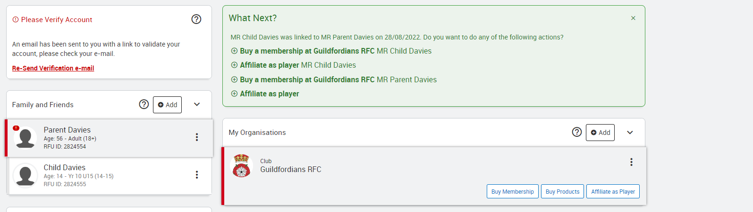
If Guildfordians RFC is not shown under My Organisations when you click on each person you will need to add Guildfordians RFC, see Add to Guildfordians RFC as an Organisation
Adding a New Junior Player to your Account
You only need to add a new player to your account once they have completed their 3 free trial sessions and want to join the club.
Login to GMS (see above for details)
Once Logged In
Click Add ‘Family Member’ and enter the players details.
You then need to Add the player to Guildfordians RFC organisation (see below)
Once the player has completed their 3 free trail sessions - please go to the Register Junior Players ( Age 3 to 18 ) section followed by Purchasing Membership.

Add to Guildfordians RFC as an Organisation
For each parent and player that will be a part of Guildfordians RFC click on them in your dashboard and if Guildfordians RFC is not shown under their My Organisations click on ‘+Add’ and search on Guildfordians RFC to add them to the Club (Organisation).
Enter Guildfordians RFC in the name field and Guildford in he City/Town field and press Seach and then select the club.
Register Junior Players ( Age 3 to 18 )
The RFU’s Registration guide can be found here : https://help.rfu.com/support/solutions/folders/103000371498
Or Quick Guide below
The RFU required all junior player to be registered each season as a part of regulation 15 within 45 days of the start of the season or joining the club (they may need to register to play in certain matches).
LogIn to GMS as previously detailed.
Once you have managed to Log In you will be on your Dashboard and should see a screen like this.
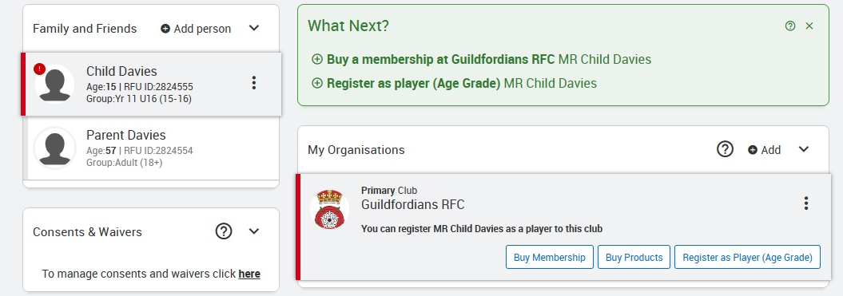

For each junior player click on ‘Register as Player (Age Grade)’ against Guildfordians RFC, if the button isn’t shown then you probably have already Registered.
Please click on each parent/guardian and make sure that their contact details (mobile number and email address are correct), click the 3 horizontal dots followed by Edit Details– if they are not correct please amend them. If any parents/guardians are missing please click Add Person to add them.
Address :
Check is your address is correct, if not you can edit it.
If more than one address is shown you can remove the incorrect or duplicate addresses.
Player Registration Details :
You and add an optional playing position if you want too.
School Details :
Please check that the correct school is shown, if not it can be added or amended (the RFU currently wont allow you to delete a school if the player is under 18 years of age).
Waivers
Click the links to find out the details and decide if you would like to give consent or not.
Medical Conditions
Add any medical conditions that the club should be aware of.
Phone Numbers
The GMS system will only display 1 phone number per person. If there is more than 1 parent / guardian please add them both with their phone numbers so that we can have both contact numbers for emergencies.
Please do not add a parents/guardians mobile phone number to a junior player.
Emergency Contacts
Either select the related adult to be the Emergency contact or enter their details manually.
Once back to the main screen press ‘Save’ to Register the player, you should then get a confirmation message.
Please repeat for each Junior player (please do not register non playing parents).

Register Adult Players ( Aged 17 or over )
The RFU’s Registration guide can be found here : https://help.rfu.com/support/solutions/folders/103000371498
Or Quick Guide below
The RFU required all adult player to be registered before taking part in any league fixtures.
LogIn to GMS as previously detailed.
Once you have managed to Log In you will be on your Dashboard and should see a screen like this.

Click on ‘Register as Player (Adult)’ against Guildfordians RFC, if the button isn’t shown then you probably have already Registered.
You will be asked to enter a number of items including medical conditions and emergency contacts.
Waivers
Click the links to find out the details and decide if you would like to give consent or not.
Medical Conditions
Add any medical conditions that the club should be aware of.
Emergency Contacts
Either select the related adult to be the Emergency contact or enter their details manually.
Once back to the main screen press ‘Save’ to Register the player, you should then get a confirmation message.
Purchase Membership
New Players paying memberships once you have completed your 3 trial sessions.
Players who were members the previous years membership is due at the start of the season.
Please also click on each parent/guardian or yourself if a adult player to make sure that the contact details (mobile number and email address are correct – press the 3 vertical dots then Edit Details) – if they are not correct please amend them. If any parents/guardians are missing for junior players please click Add Person to add them.
Click on each player one at a time, to the right of the player against club ‘Guildfordians RFC’ you should see a ‘Buy Membership’ button.
Select the right membership for the player, the system should show the right option, click the ‘Add to Basket’ button. Sibling discount should be automatically applied if purchasing more than 1 Juniors : U7s to U18s membership at the same time.
If you are adding a sibling at a later point in time please email membership@grfc.co.uk for a payment link.
If the player is starting in December or later please email membership@grfc.co.uk for a reduced payment link. If the correct membership scheme is not shown please email membership@grfc.co.uk.
If you have any other junior players repeat the above for the each of them (parents do not have to be members).
Once all Memberships are in your basket, press the ‘Checkout’ button, you then have the option to pay in full or by Direct Debit installments (there is no extra charge for this and it wont automatically renew next season).
Press the ‘Pay Now’ button.
You should get email confirmation.

More Help can be found here : https://rfu.freshdesk.com/support/solutions/articles/103000064034-new-age-grade-player-affiliation-for-a-parent-guardian

Known Problems
Account Blocked :
Email : club.secretary@grfc.co.uk with your email address / user name and we can unblock your account.

Unable to Login :
Email : club.secretary@grfc.co.uk with your email address / user name, full name, date of birth and address and we will try to find your previous account. If you have moved recently a previous address may also help.
Register Button Greyed Out :
This is normally due to you trying to login as the player rather than the parent, the account name should be displayed at the top of the screen. If this is the players name check to see if you have any other emails on any other email addresses and try the user name at the bottom of that email.
Message :
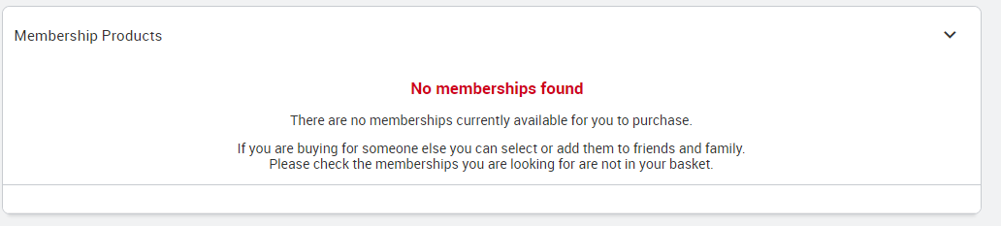
This means that you have the only membership available in your basket already and that there are no other memberships you can add. To Continue press the Checkout Icon.

Dummy Membership to resolve GMS issue do not Add to Basket :
If you get a message about a Dummy Membership after adding a Membership to your basket, press the Checkout Icon to continue as this means that there are no more valid membership schemes to choose from
If you have already selected a membership scheme but were unable to compete the payment for any reason when you try to purchase it again you can’t see the scheme. This is because it is already in your basket but it isn’t easy to find it.
In GMS click on the small circle top right in your browser it should be a picture of you if you have uploaded one, from there select product orders and you should be able to click on it to finalise the payment.
You can also select your Dashboard, scroll towards the bottom to see the unpaid orders. Click on the link and you should be able to complete the payment.
The correct membership scheme isn’t show :
Some schemes are not displayed on line – if you qualify for one oi these schemes please email : membership@grfc.co.uk from November onwards some membership schemes are removed from online purchasing.

RFU’s Known problem page :
https://help.rfu.com/support/solutions/folders/103000367056

